# **Types**

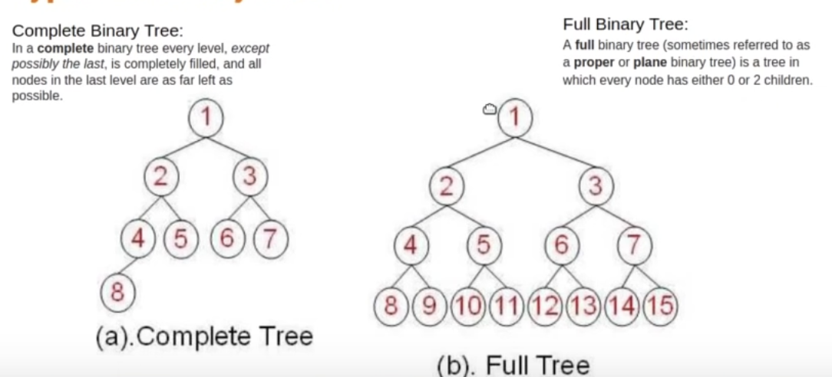

# **Data-Insertion**

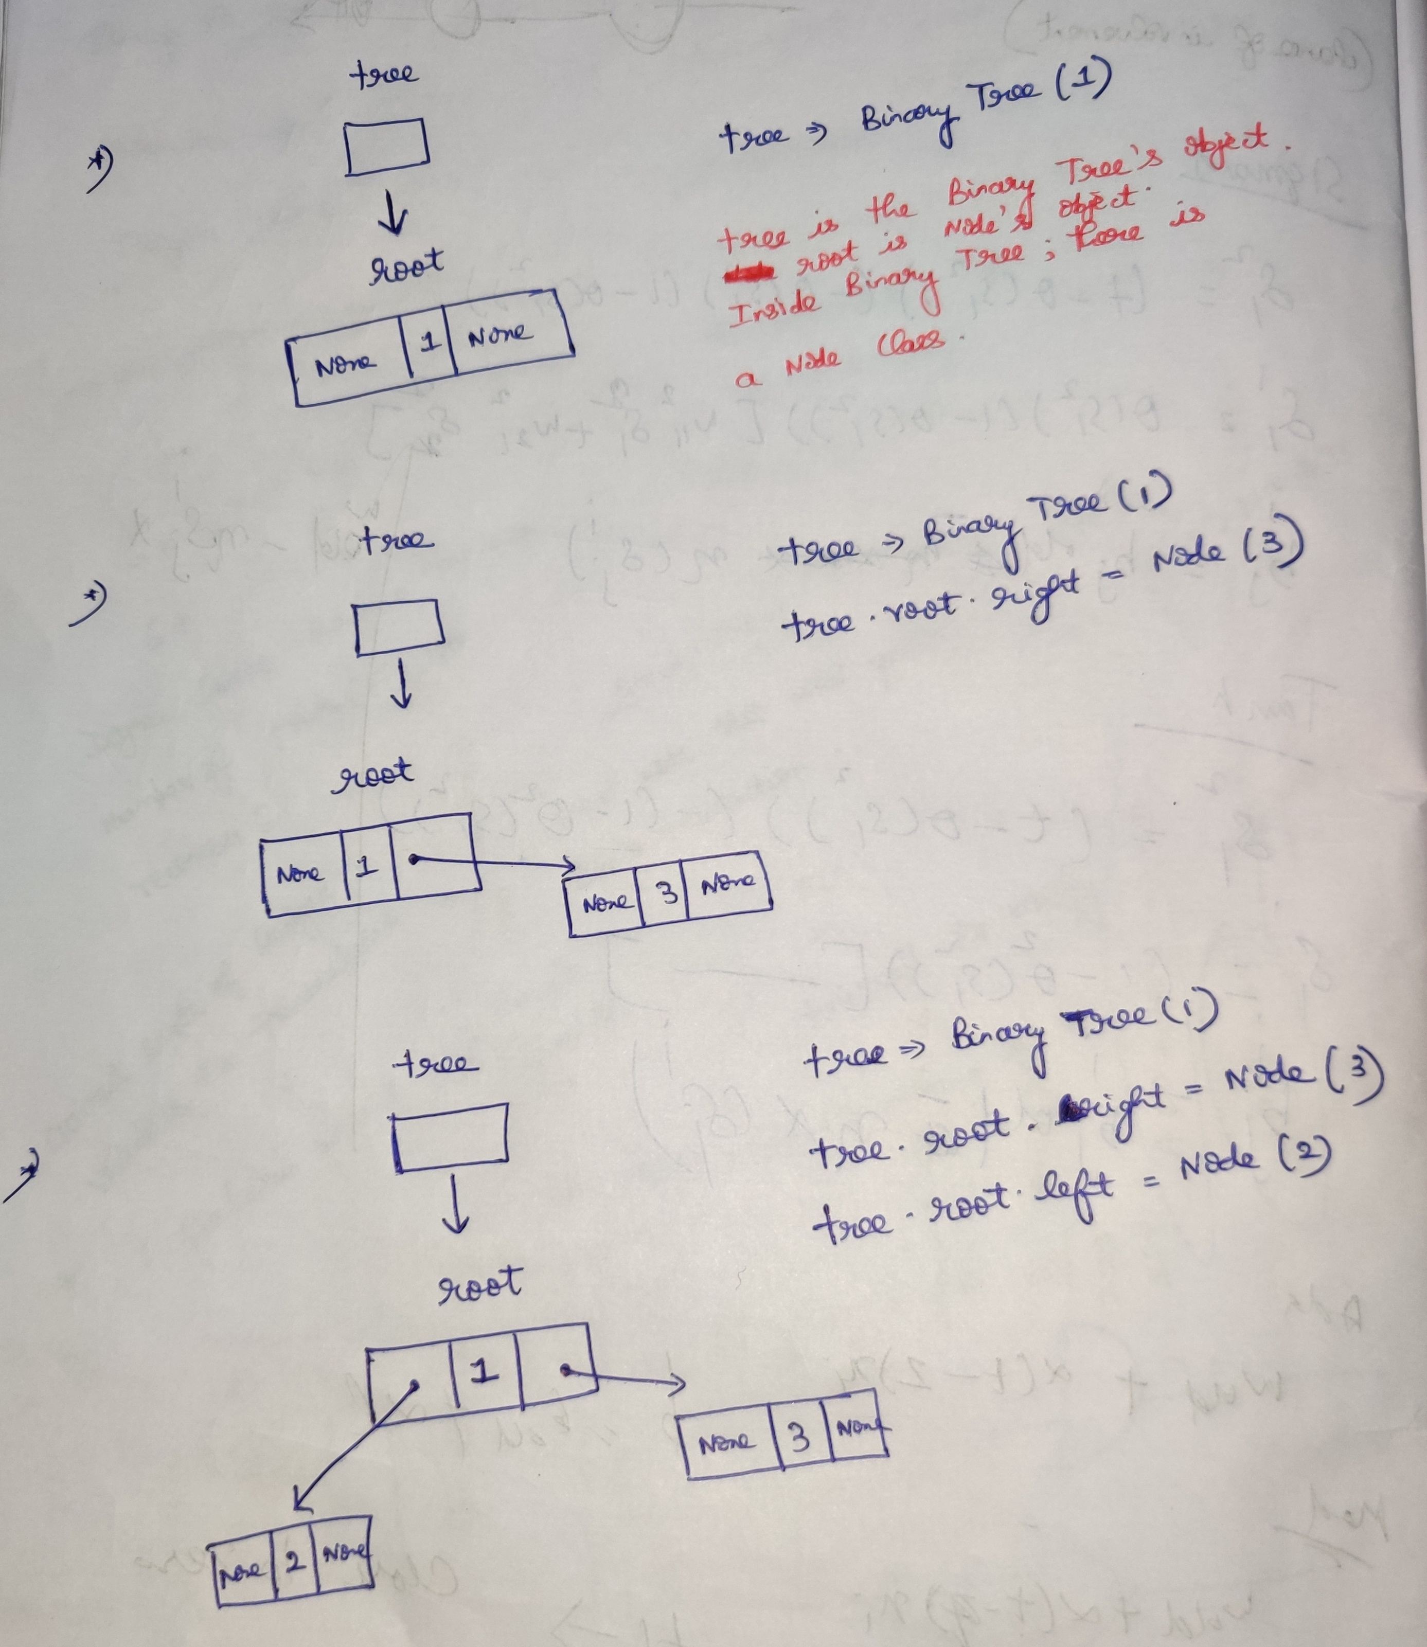

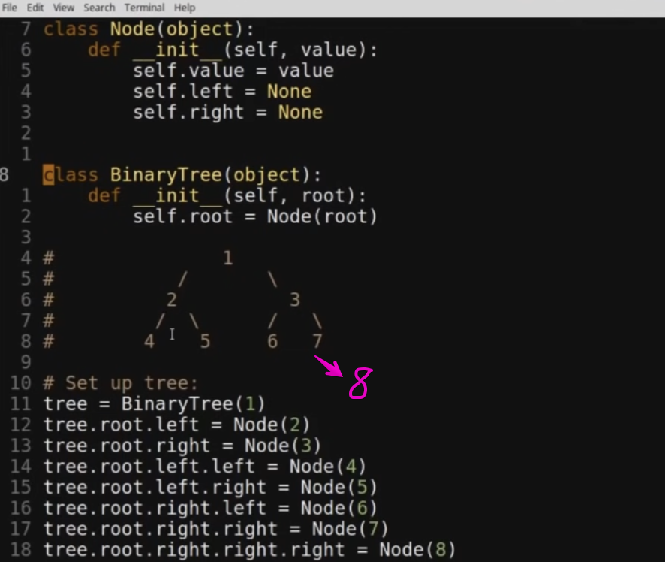

# **Tree-Traversal**

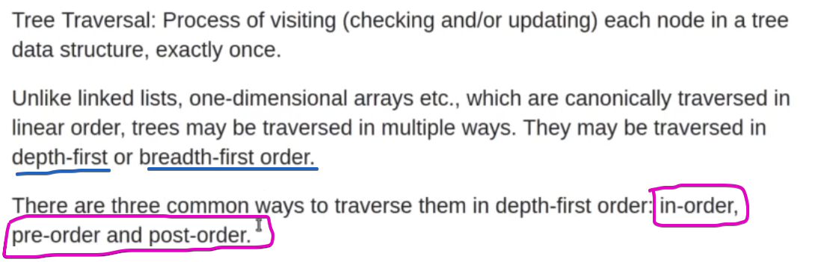

## **Pre-order Traversal**

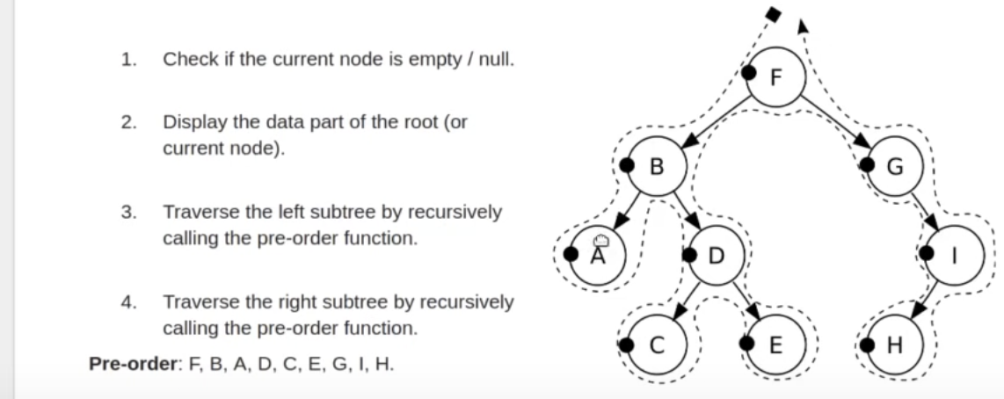

## **In-order Traversal**

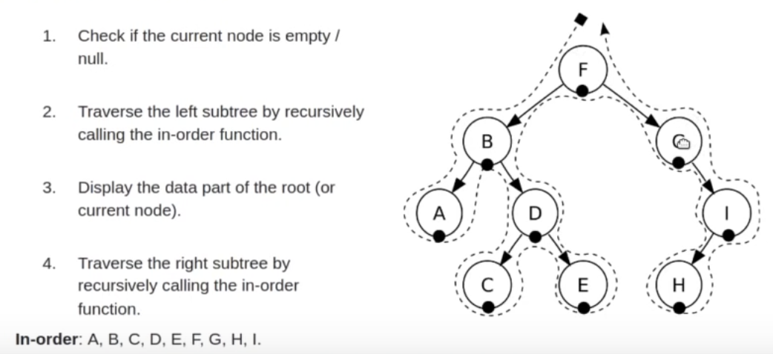

## **Post-order Traversal**

## **Lever-order Traversal**

1. Enqueue the 1st element.

Looping

1. Dequeue the element   
   a) print the element  
   b) explore

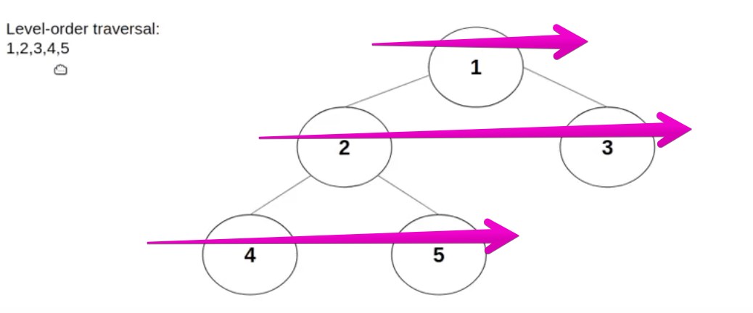

This can be implemented using queue data-structure.

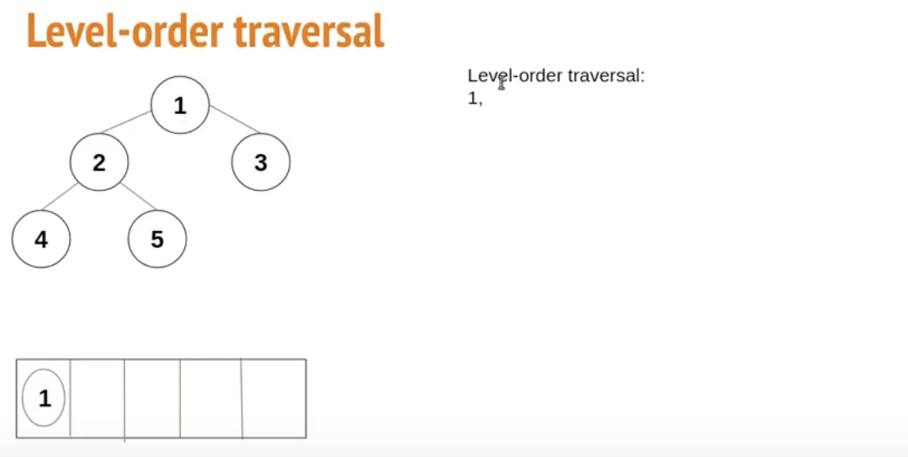  
Print element-1 and then enqueue element-1

Dequeue that element-1 and then explore its left and right children’s .

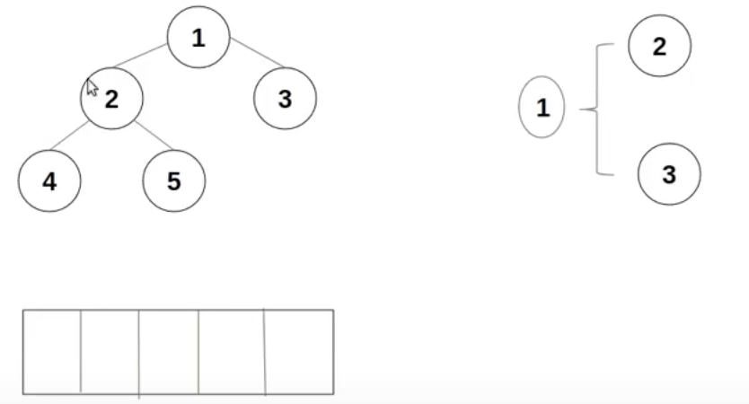

Element-1’s left children -> 2 and right children -> 3.  
So print 2, and then enqueue element-2 and 3

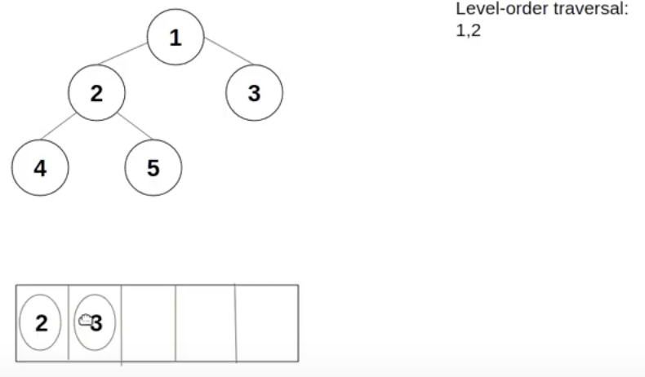

Take element-2 and explore(4,5). Enqueue element-4 and 5

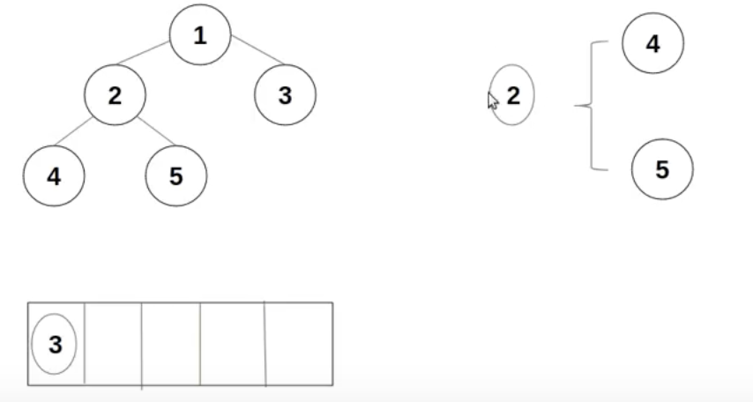

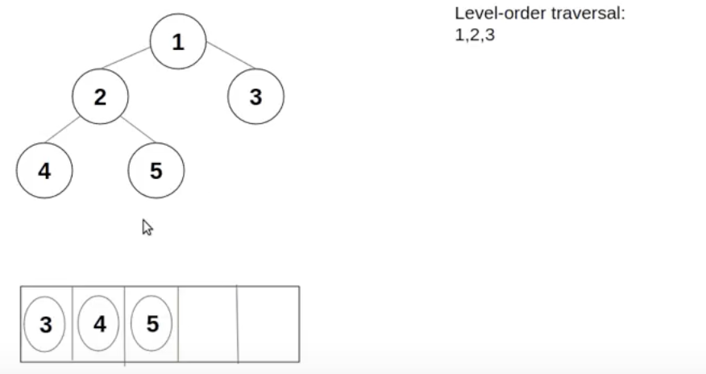

Dequeue element-3 and explore [But there is no left and right children]

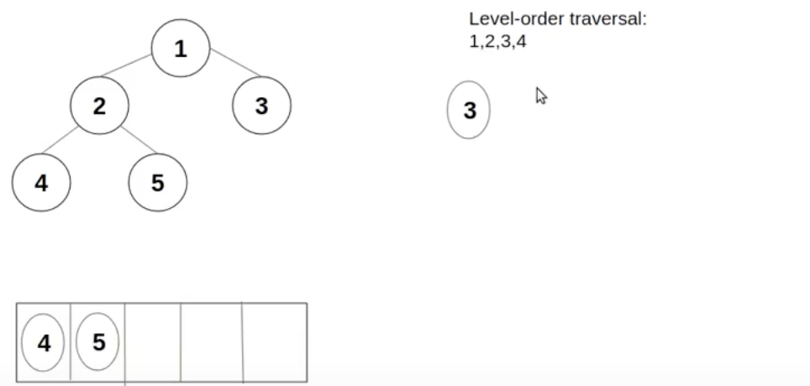

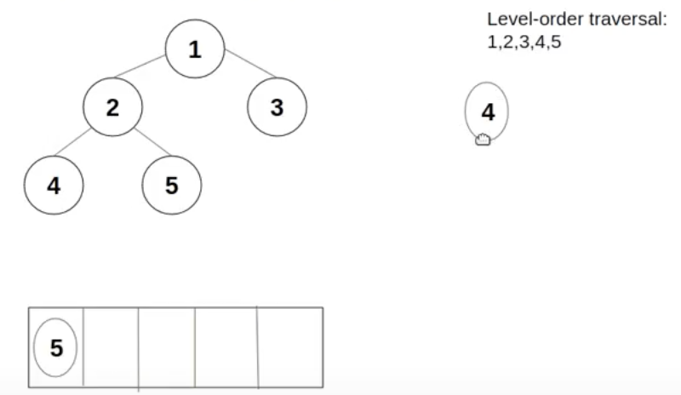

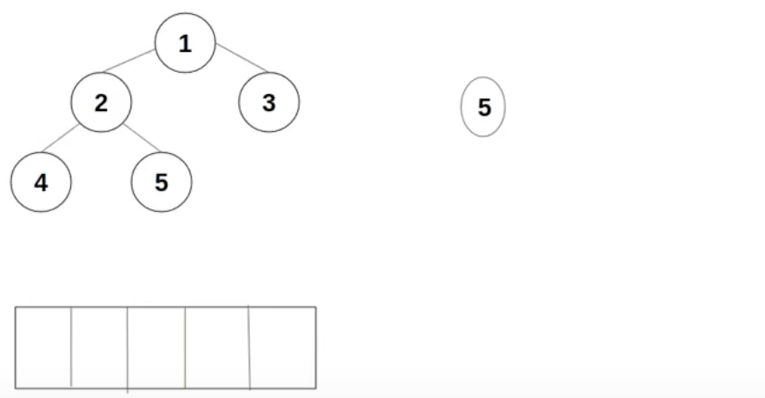

# **Reference**

<https://www.youtube.com/playlist?list=PL5tcWHG-UPH112e7AN7C-fwDVPVrt0wpV>